Technical Manual

Cargo tracing and Business Analysis

**Group Details:**

15141068- Suarabh Baj

15141074- Niyati Daftary

1514080- Jayesh Gaur

1514085 – Aditya Jawalikar

**Project Guide:**

Prof. Kiran Kumari Sinha

# Introduction

## Document Identification

This document describes the design and operating instructions of Cargo Tracing And Business Analysis Prototype. It describes how to operate, what the requirements are, what is included in the scope of this project, technology used etc.

## System Overview

The goal of the system is to manage shipments of the customers by providing them tracking of their goods using RFIDs and also giving business recommendation to cargo suppliers based on their cargo shipment order. The system has to be up and running at all times to ensure proper updation of checkpoints and tracking. Staff should be trained enough to be able to use the scanners and update the database by scanning the RFIDs. The scanners should have uninterrupted internet connection to not cause any delay. RFIDs should be cleared from database once a particular journey is over. To ensure smooth functioning of the whole system, it is really necessary for these conditions to be met at all times.

## Document Overview

* Technical details about our system
* System Requirements
* Steps to be performed
* User Manual
* System Specifications
* Safety Measures

## Reference Documents

The present document is prepared on the basis of the following reference documents, and should be read in conjunction with them.

-RFID Quick Start Guide: Arduino by ADDIKIT

-ESP8266 NodeMCU WiFi Devkit by HANDSON Technology

### Acronyms and Abbreviations

Table 1-1 lists the acronyms and abbreviations used in this document.

Table 1-1: Acronyms and Abbreviations.

|  |  |
| --- | --- |
| **Acronym** | **Meaning** |
| RFID | Radio Frequency Identification |
| WIFI | Wireless Fidelity |
| AIDC | Automatic Identification and Data Collection |
| UHF | Ultra High Frequency |

# System Description

## System Requirements

**Software Requirements:**

• Arduino: The Arduino Integrated Development Environment consists a text editor for writing code, a message area, a text console, a toolbar with buttons for common functions and a series of menus. It connects to the NodeMcu hardware to upload programs and communicate with them.

• PHP: PHP is a general purpose scripting language that is especially suited to server-side web development, in which case PHP generally runs on a web server. Any PHP code in a requested file is executed by the PHP runtime usually to create dynamic webpage content or dynamic images used on websites or elsewhere. The PHP software works with the web server, which is the software that delivers web pages to the world.This process is essentially the same when PHP is installed. You request a file, the web server happens too be running PHP, and it sends HTML back to the browser, thanks to the programming in PHP.

• Javascript: JavaScript is predominantly a client-side language used to make websites with static HTML and CSS interactive. Majority of Web-browsers supports JavaScript by the means of built-in javascript engine.

• MySQL: MySQL is an open-source relational database management system (RDBMS). MySQL is used by many database-driven web applications, including Drupal, Joomla, phpBB, and WordPress.

• Bootstrap: Bootstrap is a free and open-source CSS framework directed at responsive, mobile-first front-end web development. It contains CSS- and (optionally) JavaScript-based design templates for typography, forms, buttons, navigation and other interface components.

• Latex: Latex is a document preparation system. When writing, the writer uses plain text as opposed to the formatted text found in WYSIWYG word processors like Microsoft Word. The writer uses markup tagging conventions to define the general structure of document, to stylise text throughout a document.. A Tex distribution is used to produce an output file suitable for printing or digital distribution.

• Gantt Project: GanttProject is GPL licensed Java based, project management software that runs under the Windows, Linux and Mac OS X operating systems. A Gantt chart is a type of bar chart. Gantt charts illustrate the start and finish dates of the terminal elements and summary elements of the project. Terminal elements and summary elements comprise the work breakdown structure of the project.

**Hardware Requirements:**

• NodeMCU ESP8266: This will act as a master for the RFID scanners to read the RFID tags. The module uses a wifi signal to connect to the database and is capable of sending http requests to interact with databases and php files.

• RC522 RFID Scanner: Acts as a slave to the NodeMCU module. RFID tags will be scanned using this device.

• RFID Tags: Physical passive RFID tags for demonstration purposes.

• Jumper wires: Forms the connection between the NodeMCU and RC522

## Module Requirements:

The operational scenarios considered place certain requirements on the something system, and on the modules that comprise it.

### Functional Requirements

Login

The system will help the seller to login to the system to be able to trace the cargo shipment as and when required. For successful login to the portal, the seller has to enter the correct credentials for the username and password otherwise the system will throw error.

Register

Any seller form any country can register itself to the portal of Cargo Tracing. For this, registration process would require personal details like name, number, address, email, passport number to be entered by the seller. On successful registration, the seller would then be able to use our system. All the personal details are kept secured.

Filter

As there can be number of shipments made by the seller, the seller may need to segregate out some of the shipments made. To make this happen, the seller would have an option to filter the shipments based on the date of shipment, the month of shipment or the year of shipment.

View Timeline

The seller would be able to trace the shipment based on a timeline provided on the dashboard. The timeline specifies the shipment details such as the date of scanning of shipment at a particular time, the arrival time, the departure of the shipment and so on.

Scanning

At the checkpoints, the cargo shipment with RFID would be scanned at that location. The RFID scanner present at the checkpoint will trigger the database of the system after successful scanning of RFID stating the name of the checkpoint and the location of the same, the arrival date of the shipment and the arrival time of the shipment. The shipment would be then transferred for the further processing either to next checkpoint or it will be unloaded.

Erasing

When the shipment passes through the last checkpoint and the cargo is unloaded, the RFID tags will be erased of all the data which it collected in the whole journey from source of shipment to the destination of the shipment. These tags will be erased programmatically and all the tags will be reused again for other shipments.

### Non-Functional (Quality of Service) Requirements

Reliability

The final System will be a reliable one as it will pass through a series of testing procedures regarding the working of whole system. The trust factor of the seller relies on giving the perfect tracing of the cargo shipment along with the business analysis of the seller with high precision. The mean time of failure is very large as the deployment of web portal will be good enough to handle large requests. The probability of the system unavailability largely depends on the scanners used for RFID tags. The weather conditions mainly at port may cause hindrance in scanning and may make system unavailable for some time. Thus the rate of failure occurrence of the system is quite small.

Availability

Sometimes due to load on the server which is in process may malfunction. This may cause non-availability of the system. To recover from this inconsistent state, there will be checkpoints saved of the previous working and stable version of the system which will help in successful recovery of the system. The recovery phase of the system will not take long duration, so maximum of half hour would be required to recover the system to it’s normal state. The scanners will be available whenever required till the continuous supply of electricity is provided.

Security

This feature is important aspect of our system as the system will be used world-wide. When the seller enters critical information of identity such as the Passport number, the seller license number, these values will not be directly stored in database but with the help of cryptographic algorithms such as SHA or MD5 will be applied on those values. Every care would be taken to protect the RFID from being forged or stolen. This can be implemented by reviewing the RFID data and logs at each checkpoint.

# Implementation of Tracing System

• Step 1: Placing an order

– User logs in and places an order, sharing details about the goods he will be transporting.

– User takes his goods to the dock to start the process.

• Step2: Assigning RFID Tags

– The goods of the user are assigned RFID tags.

– Database is updated and the user’s order is now associated with a unique RFID Tag.

– The employee of the transport service will attach the RFID tag and update the database using the control panel.

• Step3: Transit

– Each checkpoint has an inbuilt scanner coded to update the order details in the database associated with the RFID it scans.

– User can use the website to check time and location using his order ID.

• Step4: Final stage

– User collects his goods at the destination.

– Order details are removed from the database and stored in a separate one which is then used to train the business analysis module.

• Step5: Complaints

– User

# Implementation of Business Analysis

• Step1: Predict profit before placing order

– User logs in to the website.

– User enters the details of the goods he plans to transport along with other attributes defining the journey.

– Application returns a percentage value of the profit he can make on that particular order.

• Step2: Predict alternative business opportunities

– New sellers could get business analysis of their new plans and ventures.

– They can easily know about which products to sell in which country and also in which seasons. The filters are user defined. It’s upto the seller how to use it.

# User Interface Design

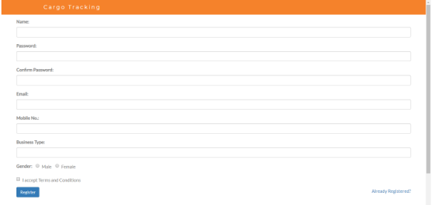



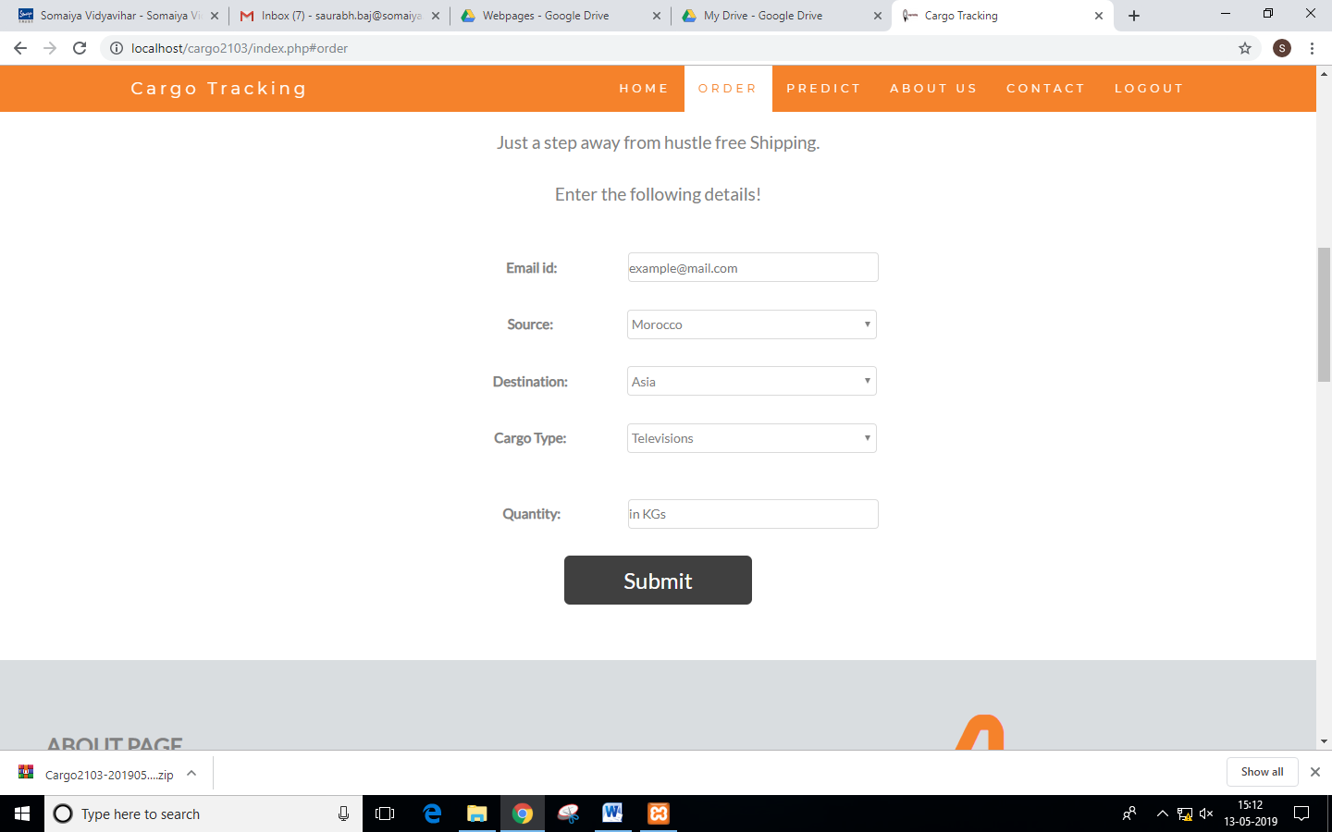

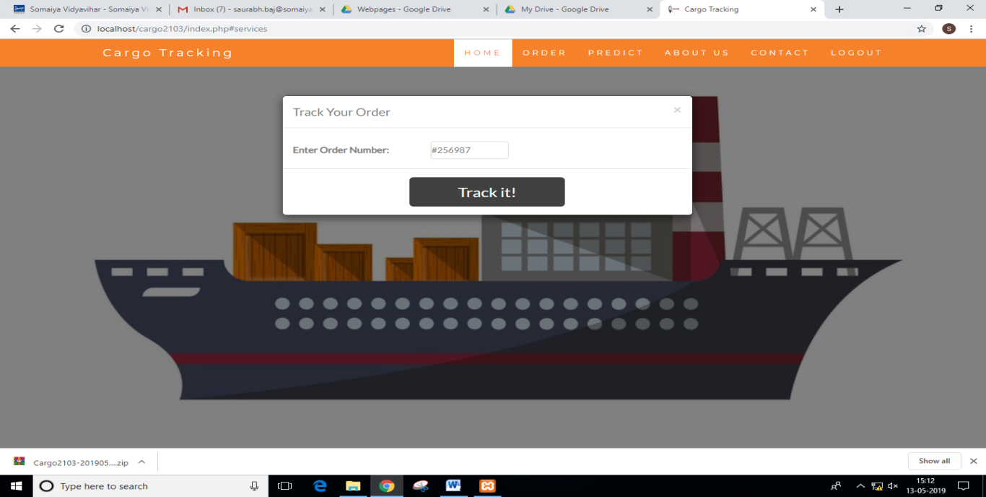

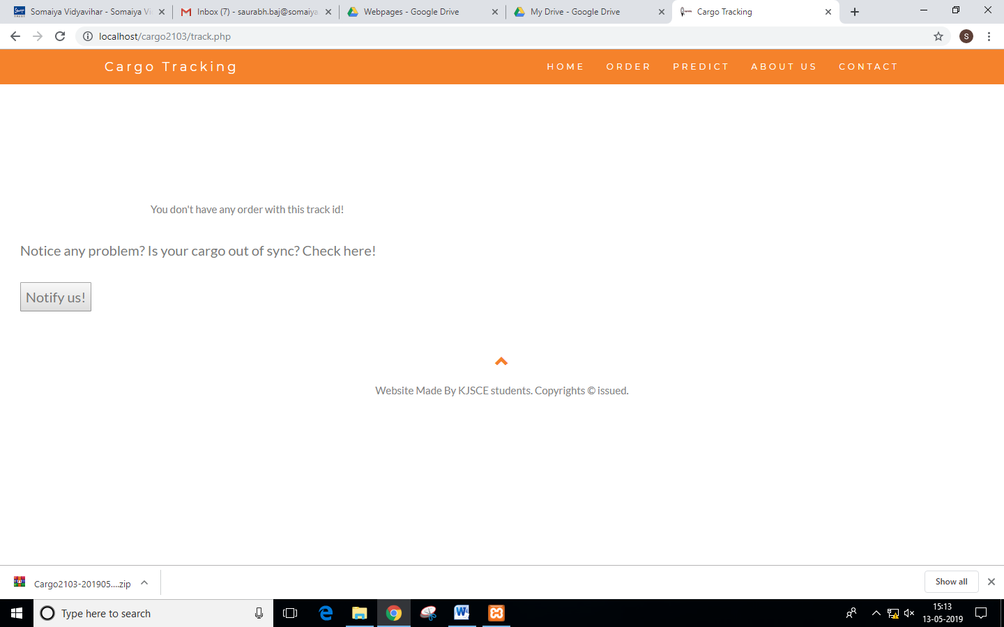

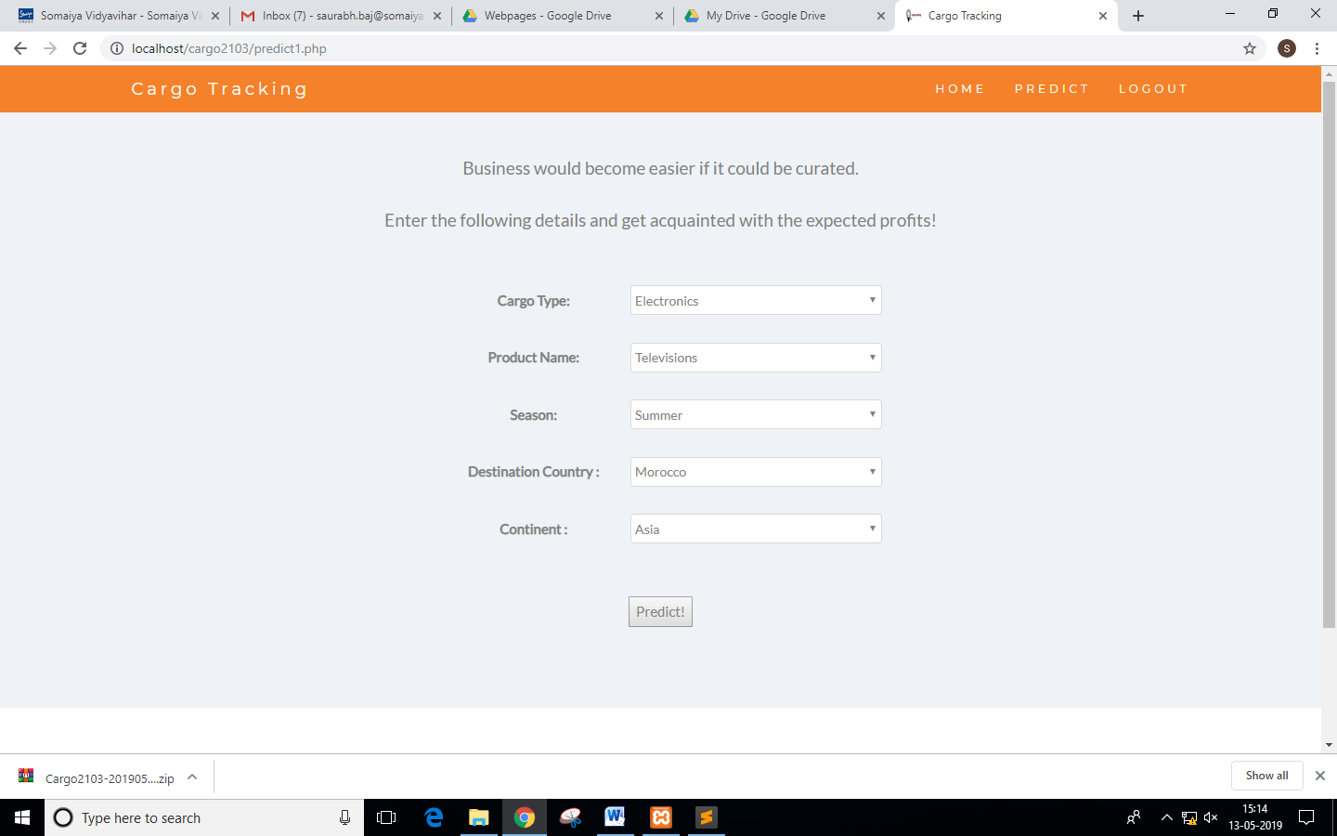

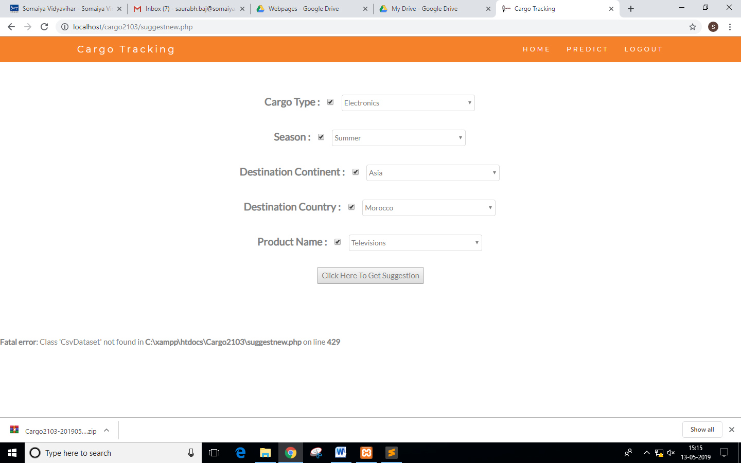

# Hardware Design

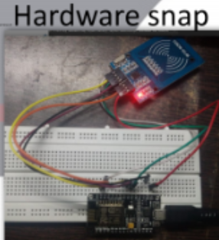

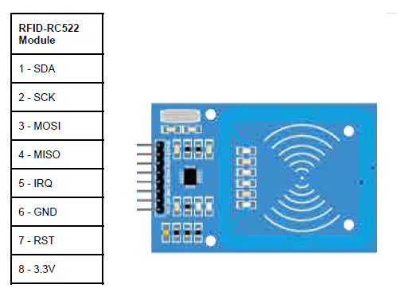

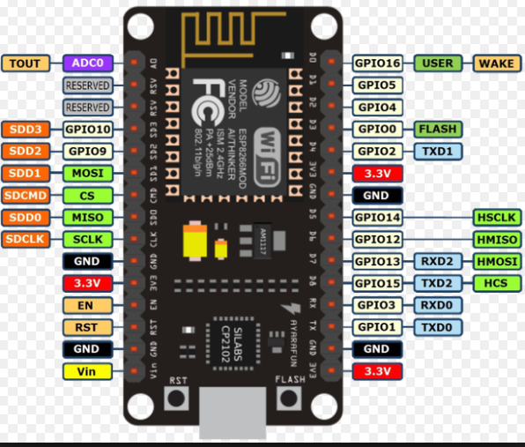

# Safety Implications

* Use RFID Scanner carefully.
* Safeguard RFIDs by using proper casing.
* Handle with care